Investment Case Report
Compagnie Financière Tradition (SIX: CFT)
Written by Corentin Marchandise, Tomas Papuga, David Nastase, Cyrille Desponds, Maxime Jaques. Not financial advice.

1. Company Overview

Business
Founded in 1959 and headquartered in Lausanne, Compagnie Financière Tradition, hereinafter referred to as CFT, is one of the world's top three interdealer brokers (IDBs) in over-the-counter (OTC) financial and commodity-related products. It employs over 2,500 staff across more than 30 countries.
The firm acts as a marketplace intermediary, facilitating transactions between financial institutions and professional traders earning commissions without taking principal risk.
CFT's revenue is split across three product categories:
- Currencies and Interest Rates (~41%): Interest rate derivatives, money markets, FX forwards, FX options and futures
- Securities and Security Derivatives (~30%): Government bonds, corporate bonds, credit derivatives, repo agreements, equities and equity derivatives
- Commodities and Others (~29%): Oil, electricity, gas, precious metals, environmental products
CFT's IDB model is inherently asset-light: revenues fluctuate with market volumes and volatility but require minimal capital deployment. The company has a joint venture network (contributing CHF 25.4M in profit in 2024) and a conservative balance sheet with net cash of CHF 282.7M as of end-2025.
The company is for the most part owned by VIEL & Cie, a Paris-based investment holding company listed on Euronext Paris.
TraditionDATA
The IDB Moat
Interdealer broking is a classic relationship business protected by high switching costs and network effects. IDBs derive their value from three sources:
- Liquidity pools: The ability to find a counterparty for an obscure OTC trade is directly proportional to the size and quality of one's dealer network. CFT's 65-year history has built relationships that are extremely difficult to replicate.
- Talent and expertise: IDB revenues are driven by skilled brokers who understand complex, illiquid instruments and client needs. These individuals are not easily replaced, and their departure would typically take client flow with them.
- Data and workflow integration: While CFT does not have the large-scale data businesses of BGC (Fenics) or TP ICAP (Parameta), its voice and hybrid brokerage services are embedded in client workflows.
Competitive Landscape
The global IDB market is dominated by four major players: BGC Group (US/UK), TP ICAP (UK), Marex, and CFT/Tradition. BGC and TP ICAP are considerably larger with market caps 3-5x CFT’s size. However, CFT has consistently grown faster organically, avoided the large-scale M&A risks that have weighed on competitors, and maintained higher ROE. Its niche focus on OTC derivatives and commodity products (areas where electronic trading has been slowest to displace voice brokerage) provides durable volume protection.
The key competitive risk is the secular digitalization of OTC markets. As electronic trading platforms (MarketAxess, Tradeweb, Bloomberg) capture an increasing market share of standardized product trading, IDBs must migrate toward more exotic, illiquid products where human expertise adds value. CFT has been executing this transition well, as evidenced by its consistent organic revenue growth.

2. Management & Governance

Leadership
At the top of the executive team, we have Michael Anderson, who serves as the CEO of the Tradition London Group and its affiliated EMEA offices. He has a background in economics and fixed-income trading and initially joined CFT as an oil broker in 2001. He then climbed the ranks until 2019 where he was promoted to CEO. Thanks to his extensive practical experience, he deeply understands the core of the business and is well-equipped to execute the firm's strategy.
Now, while Anderson handles day-to-day operations, Patrick Combes is the key to the long-term vision from the board level. Combes has been Chairman of the Board since 1997. He dictates the overall strategy through CFT’s parent holding company, VIEL & Cie, which he originally took over back in 1979. Through VIEL & Cie, Combes holds around 70% majority stake in CFT. Because he acts as a dominant, long-term owner with massive capital on the line, his interests align directly with minority shareholders.

Governance Quality
Since VIEL & Cie holds over 70% of the shares, CFT operates under a heavily centralized ownership structure. For that reason, the strategic direction is dictated by its parent company. This concentration of capital ensures that the leadership is deeply invested in the firm's long-term survival. They prioritize a safe approach to debt and steady profit reinvestment. Having a dominant shareholder means that minority investors have less voting power, but the Board of Directors balances this by including independent members who provide additional oversight.

Share Buybacks and Capital Accumulation
CFT’s approach to capital allocation is highly efficient for investors. They actively return cash through a mix of dividends and share buybacks. For instance, in the last 3 years the Board conducted a buyback program targeting up to 300k shares. In its FY2025 report, the firm also mentioned that they are considering a new share buyback program. Alongside these repurchases, CFT maintains a steady dividend and frequently provides a stock dividend option. This setup allows investors to reinvest their payouts, taking full advantage of compound interest over time while the firm keeps its balance sheet highly secure.

3. Financial Performance
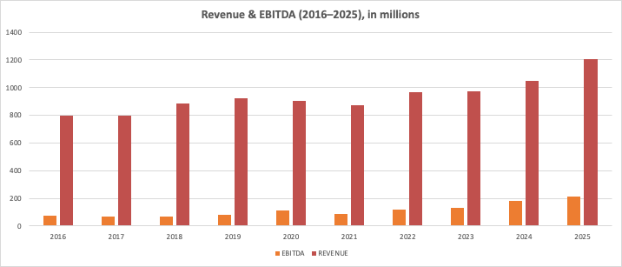

Revenue Growth
CFT's revenue has gone from about CHF 796m in 2017 to about CHF 1.203bn in 2025. That's a 4.7% CAGR on that 9-year-period. We can see from the chart that revenue growth has been sluggish until 2021, partially due to Covid-19. Growth has clearly accelerated since 2021, with a 8.2% 4-year-CAGR, the main driver being central banks moving off zero rates pushed up trading volumes in rates, FX and credit. Geopolitical and tariff environment starting in 2025 with Trump’s comeback as president has also boosted trading volumes in rates, FX and credit, which are CFT’s strongest asset classes.
2025 revenue increase: +11.4% ; 2025 EBITDA increase: +24.6%

Profitability and Margins
Operating margin has grown from 6.5% in 2018 to 13.8% in 2025. Net profit margin moved from 5.7% to 12.1% over the same span. Net income went from CHF 51m to CHF 134m, a 14.8% annual pace. These numbers are very good for a IDB. The net profit margins values of its 2 direct peers in 2025, TP ICAP and BGC, are 8.1% and 5% respectively, and have been much worse over the past 5 years. CFT is the best of the 3 in terms of profitability metrics. ROE has only grown in the last 10 years, eg. 28% in 2025 compared to 17% in 2021. ROA 11.6% in 2025. ROIC 14.6% in 2025.
It is important to mention that profitability of interdealer broker (IDBs) depend on macro-economic stress. Hence, in periods of high volatility, like recently, CFT is large beneficiary, not a victim.

Balance Sheet
The balance sheet is one of the strongest in the sector. Strong liquidity position, high levels of cash and short-term assets. Net cash was CHF 330m at end-2025.
Low leverage, net D/E is close to zero. Debt-to-Equity ratio is 0.5x, which is very low and unusual for a financial company, who often use leverage. CFT also has a solid equity base relative to its size. Consistent between retained earnings and dividends. Practically, nothing on the balance sheet would stop CFT from engaging in an acquisition, paying a special dividend, or absorbing a weak year.
Quick ratio 2025: 1.98 & current ratio 2025: 2.04 were stable over the last 5 years.

Dividends
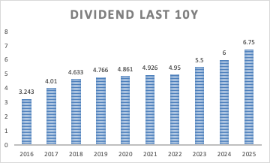
CFT has paid a stable or rising dividend every year for over a decade. They pay one dividend per year, usually around the month of May. The average increase in dividend per share in the last 4 years is about 11% per year. The interesting bit is that the payout ratio has actually shrunk, from 57% in 2021 to 39% in 2025, because EPS has grown faster than the dividend. Hence, the group has plenty of room to keep raising the dividend even if 2026 earnings flatten. Furthermore, the dividend yield has compressed from 5–6% historically to about 2.6%, all of it driven by share-price appreciation rather than a payout cut. CFT also pays the occasional treasury-share distribution on top, though that's discretionary.
Next cash dividend will be on May 26th of the amount CHF 7.50 (yield of 2.56%)

4. Valuation
Premium Yet Justified P/E
Compagnie Financière Tradition currently trades around CHF 286.50 per share, implying a market capitalization of roughly CHF 2.2bn. On valuation, the stock trades at approximately 16.3x 2026 earnings and 15.4x 2027 earnings. This is not cheap compared to traditional brokers, but the premium is understandable given that CFT is not a balance-sheet-heavy financial institution. It operates as an asset-light interdealer broker with a strong net cash position, limited principal risk, and high profitability.
The company also screens as expensive on simple multiples because it has already performed strongly. However, this does not necessarily imply overvaluation. CFT’s earnings base has improved materially, with 2025 revenue reaching CHF 1,203.6m, EBITDA CHF 209.9m, and group net profit CHF 134.2m, supporting the current valuation through real earnings growth rather than purely multiple expansion.
Peer Comparison
The relative valuation is best understood by comparing CFT across three key multiples: P/E, EV/EBITDA, and P/FCF.
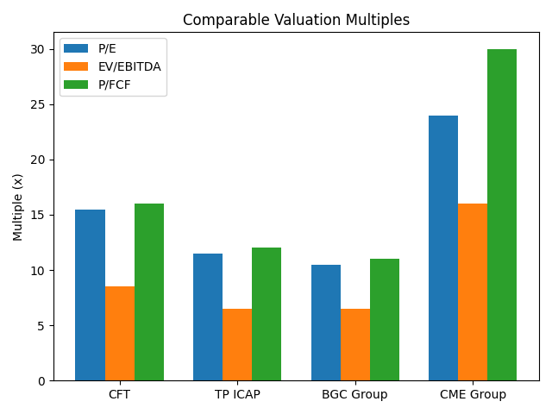
Compagnie Financière Tradition trades at approximately 15.5x earnings, compared to 11.5x for TP ICAP and 10.5x for BGC Group, implying a premium of roughly 35–45% over traditional interdealer broker peers. Similarly, on an EV/EBITDA basis, CFT trades at around 8.5x, versus approximately 6.5x for both TP ICAP and BGC, confirming a consistent valuation premium across key metrics.
However, when compared to financial infrastructure and exchange operators such as CME Group, which trades at approximately 24x P/E, 16x EV/EBITDA, and 30x P/FCF, CFT still trades at a discount of around 30–40%. This positioning highlights that the market continues to value CFT primarily as a brokerage business, even though its economics and strategic direction increasingly resemble those of hybrid infrastructure and data-driven platforms.
As a result, while traditional broker comparisons justify the current premium, the discount to exchange operators suggests limited but tangible re-rating potential, rather than a deep mispricing. This interpretation is consistent with analyst price targets, which imply only modest upside from current levels.
Intrinsic Value and Price Target
The current market consensus is not particularly aggressive. Analysts’ average 12-month price target stands at approximately CHF 292.33, compared with the current share price of CHF 286.50, implying only around +2% upside. The high analyst target of CHF 314 suggests roughly +10% upside, while the low target of CHF 258 implies around -10% downside. Overall, the sell-side view is closer to “fairly valued” than “deeply undervalued.”
A conservative valuation framework supports this view. Assuming forward earnings of approximately CHF 18 per share, a 16x P/E multiple implies a value of around CHF 288, which is broadly in line with the current share price. This indicates that the stock is already supported by reasonable base-case assumptions.
However, automated DCF-based valuation platforms suggest a more optimistic picture. AlphaSpread estimates CFT’s intrinsic value at approximately CHF 468 per share, including a DCF value of around CHF 482, implying significant upside compared with the current market price. Similarly, Simply Wall St estimates CFT’s future-cash-flow fair value at around CHF 426 per share, also suggesting that the stock trades below its DCF-implied value. These estimates support the upside case, although they should be treated as optimistic scenarios because they depend heavily on long-term growth and discount-rate assumptions.
The upside case therefore depends on two possible drivers. Under a traditional multiple-based approach, upside remains relatively limited, with a 17–18x P/E multiple implying a valuation of approximately CHF 306–324 per share. However, the DCF-based valuations from AlphaSpread and Simply Wall St suggest a more optimistic scenario, where stronger long-term cash-flow generation could justify a substantially higher intrinsic value.
Overall, the investment case is therefore not based on deep undervaluation under conservative assumptions. Instead, CFT appears broadly fairly valued on traditional multiples and analyst targets, while automated DCF models suggest a more positive upside scenario. The stock’s attractiveness depends mainly on whether the company can sustain earnings growth, maintain strong profitability, and gradually convince the market to value it more like a high-quality financial infrastructure business.

5. Catalysts: why CFT and why now?
Main Catalysts
CFT is one of the world’s top three inter-dealer brokers (IDBs). The company facilitates trades between investment banks and financial institutions, earning commissions on transactions.
Given the current financial and geopolitical environment, interest rates across central banks are highly volatile. This creates increased demand for large-scale capital movements between institutions—a trend that is likely to persist in the near future. As a result, CFT’s business model benefits from periods of market instability and uncertainty, making it a potential hedge against underperforming equities.
CFT is also actively investing in the digitalization of its IDB services, improving execution speed, increasing margins, and reducing operational risks (such as well-known “fat-finger” trading errors). Hybrid platforms like ParFX, which combine electronic trading with voice broking, and Trad-X, focused on interest rate swaps, illustrate this strategy. These platforms leverage both human expertise and algorithmic decision-making.
Through its TraditionDATA division, which operates in over-the-counter (OTC) markets, CFT is expanding into proprietary market data services. This segment offers strong recurring revenue potential, with operating margins of approximately 60–80%, compared to 10–12% for traditional brokerage commissions. By processing and structuring non-public derivatives data—including interest rate swaps, FX options, and other instruments—CFT enhances market transparency and usability for clients.
Why invest now?
CFT’s business model is particularly well-suited to the current environment of elevated uncertainty, which is likely to persist over the next few years. In addition, its ongoing technological advancements—particularly hybrid trading systems and its TraditionDATA offering—position the company competitively within the brokerage industry. Its platforms are widely adopted across major financial institutions, reinforcing its strong market position.

6. Risks
The risks associated with CFT are closely tied to the same factors that make it an attractive investment opportunity. The company’s core brokerage business relies heavily on transaction volumes, meaning that during periods of market stability—particularly when interest rates flatten and volatility declines—trading activity tends to decrease. This directly impacts commission revenues. While this cyclicality is a structural feature of the business, it is partially mitigated by the growth of its TraditionDATA division, which generates more stable and recurring revenues. However, this segment remains relatively small for now, representing an estimated 6–8% of total revenue in 2025, although it contributes a higher share of operating profit (around 15–20%). As such, it cannot yet fully offset a prolonged slowdown in brokerage activity.
Regulatory pressure on OTC Markets
Another important risk stems from the regulatory environment surrounding over the counter (OTC) markets. CFT operates in a space where transactions are less transparent and more customized than on public exchanges, giving inter-dealer brokers a competitive advantage through access to information and client relationships. However, regulators such as the EUMA and the SEC have consistently pushed for greater transparency and standardization, including efforts to move certain OTC products onto centralized exchanges. Such developments could reduce information asymmetry and allow institutions to bypass intermediaries, potentially weakening the traditional IDB model. That said, CFT’s ongoing transition toward electronic platforms and data-driven services may help mitigate this risk, as clients are likely to prioritize execution quality, speed, and integrated solutions over simply migrating to alternative venues.
Forex and currency translation implied risks
CFT is headquartered in Switzerland and reports all retained earnings in CHF, most of their income activity (fees, IRR) are in other weaker currencies like USD, JPY, EUR. Firstly, in 2025 their revenue grew by 11,4% yet the IFRS reporting said only 6,1% in CHF. The growth did happen, yet the reported growth was almost half. Secondly, the exchange rates are in favour of selling CHF not buying, since the CHF remains strong in these times of inflation and uncertainty. In 2025, a net loss of 7,1 million CHF due to exchange effects, compared to 0,4 million CHF loss in 2024 where there was less volatility. Self-hedging here is not as good of an option, since continuous hedging against CHF is expensive, to a degree CFT is a victim of its own geography. Nevertheless, losses are outweighed by the total profits. In 2024 0,423% of total profits were lost and in 2025 it was 0,693, but there was a 6,4 million increase in revenue shielding from the perceived loss.
Compliance and operational Risks
Finally, there are compliance and operational risks inherent to operating in largely private markets. Regulatory authorities closely monitor activities related to anti-money laundering and counter-terrorist financing, as well as trade reporting and transparency requirements. Even minor errors can attract scrutiny, making continuous investment in compliance systems essential. These risks are not specific to CFT but rather to the nature of the business itself. The company’s ability to maintain strong internal controls and adapt to evolving regulatory expectations will remain an important factor in managing this exposure.
Overall, while CFT is exposed to cyclical, regulatory, and operational risks, its strategic shift toward higher-margin data services and technology-driven platforms provides a degree of resilience and positions it to better navigate these challenges over time.

7. Bottom Line
A Strategic Play on Market Volatility
Compagnie Financière Tradition (CFT) represents a high-conviction buy-and-hold opportunity for an investment horizon exceeding three years. It is uniquely positioned to transform current market chaos into a significant advantage. As a top-tier interdealer broker, the firm acts as a primary beneficiary of macro-economic stress; while other sectors may struggle, CFT thrives on the volatility that drives institutional trading volumes. This investment proposal prioritizes superior quality metrics, including a 27.6% ROE, expanding profit margins, and a fortress-like net cash position, over simple valuation cheapness.
This position would let us benefit from CHF exposure to the IDB sector with SIX Exchange liquidity and consistent analyst coverage, all without the burden of currency or holding structure complexity. By trusting in management’s proven organic growth strategy, we engage with a compounding, shareholder-friendly business that provides a resilient hedge and long-term value in an increasingly unstable financial environment.

